# TRAFFIC MANAGEMENT

**PROBLEM STATEMENT:**

Urban areas around the world are facing increasing traffic congestion, leading to numerous problems such as longer commute times, air pollution, and decreased quality of life. The need for efficient traffic management solutions has never been more critical. This project aims to address these challenges by developing and implementing innovative traffic management strategies and technologies in urban environments.

**KEY OBJECTIVES:**

1. **Congestion Reduction:** Develop algorithms and systems to reduce traffic congestion in urban areas during peak hours, enhancing the flow of vehicles and reducing travel times.
2. **Traffic Flow Optimization:** Implement intelligent traffic signal control systems that adapt to real-time traffic conditions to optimize the flow of vehicles on major roadways.
3. **Public Transportation Integration:** Integrate public transportation systems with traffic management solutions to encourage the use of public transit, reduce the number of private vehicles on the road, and decrease congestion.
4. **Emission Reduction:** Implement eco-friendly traffic management strategies to reduce greenhouse gas emissions, improving air quality and addressing environmental concerns.
5. **Data Analysis and Prediction:** Utilize advanced data analytics and predictive modeling to anticipate traffic patterns, accidents, and road closures, allowing for proactive traffic management.
6. **Safety Enhancement:** Develop systems that enhance road safety by detecting and mitigating potential hazards, reducing the likelihood of accidents.
7. **Infrastructure Maintenance:** Implement maintenance and repair strategies to ensure that road infrastructure is in optimal condition, reducing disruptions due to roadwork.

1. **User-Friendly Information:** Create user-friendly mobile applications and information platforms that provide real-time traffic updates, alternative routes, and travel advisories to empower commuters with accurate information.
2. **Cost-Efficiency:** Optimize the allocation of resources and budgeting for traffic management projects to ensure cost-effective solutions.
3. **Stakeholder Collaboration:** Foster collaboration between government agencies, transportation authorities, and technology companies to create a comprehensive and integrated traffic management ecosystem.

**INNOVATIVE IDEAS:**

1. **Smart Traffic Signal Control System:** Develop a system that uses real-time traffic data and artificial intelligence to optimize traffic signal timings, reducing congestion and improving traffic flow.
2. **Predictive Traffic Analytics:** Create a predictive analytics platform that forecasts traffic congestion based on historical data, events, and weather conditions, allowing commuters to plan their routes accordingly.
3. **Traffic Incident Detection:** Implement an automated system that uses cameras and sensors to detect traffic incidents such as accidents or road debris and alerts authorities for faster response and resolution.
4. **Dynamic Toll Pricing:** Develop a dynamic toll pricing system that adjusts toll fees based on real-time traffic conditions, encouraging off-peak travel and reducing congestion during rush hours.
5. **Public Transportation Integration:** Create an app that integrates multiple modes of public transportation (buses, trains, subways) into a single platform, making it easier for commuters to plan and pay for their journeys.
6. **Traffic Data Crowdsourcing:** Develop a mobile app that allows users to report traffic conditions, accidents, and road closures, providing valuable real-time data to traffic management authorities.
7. **Electric Vehicle (EV) Charging Infrastructure Management:** Design a system that manages EV charging stations to ensure efficient use and reduce congestion at popular charging locations.
8. **Smart Parking Solutions:** Create a smart parking system that uses sensors to detect available parking spaces and guides drivers to them, reducing the time spent searching for parking.
9. **Pedestrian Safety Enhancement:** Implement pedestrian-friendly infrastructure, such as smart crosswalks with real-time countdowns and signals that adjust based on foot traffic.
10. **Urban Mobility Hubs:** Design and build urban mobility hubs where various transportation options (bikes, scooters, rideshares, public transit) converge, making it easier for commuters to switch between modes.

# Introduction:

# Traffic management refers to the process of controlling and regulating the movement of vehicles, pedestrians, and other forms of transportation within a specific area or on a network of roads and streets. It is a crucial aspect of urban planning and transportation engineering, with the primary goal of ensuring the safe and efficient flow of traffic. Here is an introduction to some key aspects of traffic management

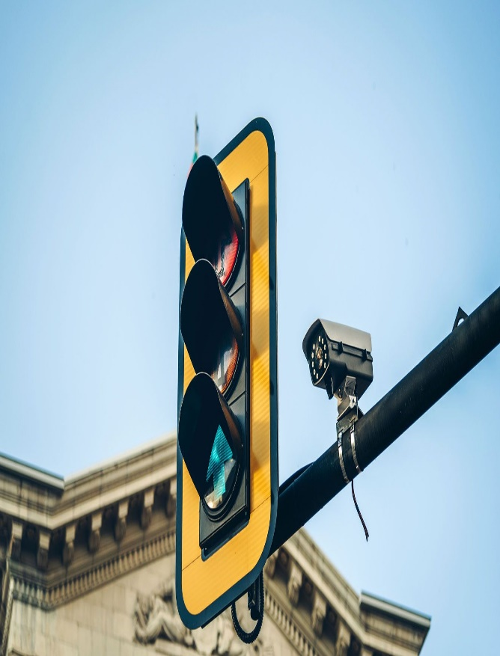 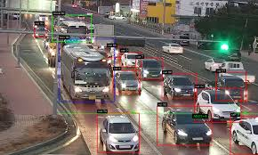

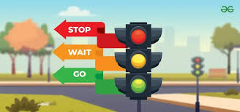

# Ideology:

# Traffic signals aim to improve the efficiency of traffic flow. They help allocate time and space at intersections, ensuring that vehicles and pedestrians can move through the area with minimal delays and congestion. This efficiency is particularly crucial in urban areas with high traffic volumes.

# Traffic signals are designed to control and manage conflicting movements at intersections. By assigning specific times and right-of-way to different traffic streams, signals prevent dangerous situations where vehicles might collide if not properly regulated.

# Components Required:

* LCD Display
* Bread Board
* USB Cable
* Wires
* Arduino Uno

# STEPS:

1. Traffic Sensor Installation: Setting up sensors that senses the traffic dense in several regions Install cameras at entry and exit points of regions for vehicle recognition.

2. Data Collection and Transmission: Develop the necessary hardware and software infrastructure to collect data from sensors and cameras. Implement a reliable data transmission protocol to send information to a central server in real-time.

3. Real-Time Management Platform: Design and develop a user-friendly mobile app for Android and iOS platforms. Implement a visually appealing and intuitive user interface that allows users to: View real-time tracking of travelling traffic dense on a map. Receive notifications and updates on location and its traffic updates.

4. Backend Development: Create a robust backend system that receives, processes, and stores data from sensors and cameras. Develop algorithms for real-time location prediction, ensuring efficient safety utilization. Implement features for monitoring and managing the whole system’s operations.

5. Integration with Sensors and Cameras: Ensure seamless integration between the backend system and safety sensors and cameras. And also fast connection with sensors and servers.

6. Automated Entry/Exit Systems: Implement sensors for recognition systems at entry and exit points of regions. Integrate these systems with the central server for automated access control.

7. Testing and Optimization: Conduct extensive testing of the entire system to ensure reliability and accuracy of sensor data. Perform load testing to ensure the system can handle many users.

8. Scalability and Adaptability: Design the system architecture with scalability in mind to accommodate multiple transport live data's and increasing user demand. Develop clear documentation and protocols for future expansion and maintenance.

9. Security and Privacy Measures: Implement robust security measures to protect user data, payment information, crud information (in case of any accidents too) and system integrity. Ensure compliance with data protection regulations and privacy standards.

10. Data Analytics and Insights: Utilize historical data collected from sensors to gain insights into route patterns, peak travel times, and user behavior. Use these insights to make data-driven decisions for future improvements and expansions.

**SOURCE CODE:**

Building an IoT traffic monitoring system involves several steps, from deploying Ultrasonic sensors to developing the software to collect and transmit traffic data to a central platform. Here's a high- level overview of the process:

**Python Script for Data Collection:**

Developing a Python script for each IoT device to collect traffic data. The exact script will depend on the type of device and sensor being used. Below is a generic example using a simulated traffic sensor:

Python program: import time import random import requests

device_id = "your_device_id"

sensor_type = "traffic_flow_sensor"

while True:

# Simulate data collection (replace this with actual sensor data) traffic_data = {

"device_id": device_id,

"sensor_type": sensor_type,

"timestamp": int(time.time()),

"traffic_flow": random.randint(0, 100), }

# Send data to the traffic information platform

response = requests.post("https://your-traffic-platform-api-url",

json=traffic_data)

if response.status_code == 200:

print("Data sent successfully")

else:

print("Failed to send data")

# Innovation:

# DESIGN:

Urban areas around the world are facing increasing traffic congestion, leading to numerous problems such as longer commute times, air pollution, and decreased quality of life. The need for efficient traffic management solutions has never been more critical. This project aims to address these challenges by developing and implementing innovative traffic management strategies and technologies in urban environments. So, we are creating a app for displaying the traffic dense on the several regions as the users need it

**STEPS:**

**Traffic Sensor Installation:**

* Implement advanced sensors with the ability to detect not only traffic density but also weather conditions, road surface quality, and other factors affecting traffic.
* Consider the use of IoT (Internet of Things) devices for easy connectivity and remote management of sensors.
* Explore the possibility of using AI-driven sensors for automated anomaly detection and real-time incident reporting.

**Data Collection and Transmission**:

* Develop data compression techniques to reduce the amount of data transmitted without compromising accuracy.
* Implement data redundancy and backup strategies to ensure data integrity and availability in case of hardware or network failures.
* Consider edge computing solutions to process and filter data at the sensor level, reducing the burden on the central server.

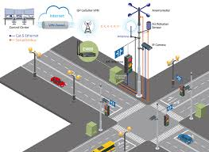

**Real – Time Management Platform:**

* Integrate augmented reality (AR) features to provide users with live traffic data overlaid on their smartphone camera, enhancing their navigation experience.
* Offer a user-friendly dashboard for city administrators to monitor and manage traffic flow in real-time.
* Explore voice-command integration for hands-free interaction with the app while driving.

**Backend Development**:

* Implement machine learning algorithms for dynamic traffic management, such as adjusting traffic signals in real-time based on traffic density.
* Utilize block chain technology to secure and authenticate data transactions, enhancing the system's transparency and security.
* Develop a Restful API to allow third-party developers to build applications on top of your traffic data, fostering innovation and expansion.

**Integration with Sensors and Cameras:**

* Incorporate machine vision and object recognition techniques to not only detect vehicles but also identify and classify them by type (e.g., cars, trucks, bicycles).
* Implement real-time anomaly detection in camera feeds to identify accidents or road obstructions immediately.
* Consider the use of drones equipped with cameras for aerial traffic monitoring, especially in congested areas.\

**Automated Entry/Exit Systems:**

# Integrate biometric authentication or license plate recognition for seamless entry and exit at controlled access points.

# Implement dynamic pricing strategies based on real-time traffic conditions to manage congestion effectively.

# Explore the use of smart city infrastructure, such as RFID (Radio-Frequency Identification) technology, to enhance automated entry/exit systems.

**Testing and Optimization:**

* Implement A/B testing to evaluate the effectiveness of different user interfaces and features to optimize user engagement.
* Use machine learning for predictive maintenance to anticipate and prevent potential sensor or hardware failures.
* Employ AI-driven load testing to simulate extreme usage scenarios and identify system weaknesses.

**Scalability and Adaptability:**

* Adopt a micro services architecture to enable easy scalability of individual components, allowing you to add resources as needed.
* Explore edge computing in the form of fog computing, where processing occurs closer to the data source, reducing latency and enabling rapid scalability.

**Security and Privacy Measures:**

* Use biometric authentication and two-factor authentication for secure access to sensitive data within the app.
* Employ advanced anomaly detection algorithms to identify and respond to potential security breaches in real-time.
* Collaborate with cybersecurity experts to conduct regular security audits and penetration testing.

**Data Analytics and Insights:**

* Utilize advanced predictive analytics to provide users with accurate travel time estimates, considering real-time traffic conditions, weather, and other factors.
* Offer an API for local businesses and advertisers to access anonymized and aggregated traffic data for market research and targeted advertising.

# HTML CODE TO CREATE A PLATFORM THAT DISPLAYS REAL – TIME TRAFFIC INFORMATION

<!DOCTYPE html>

<html>

<head>

<title>Real-Time Traffic Information</title>

<script src="https://maps.googleapis.com/maps/api/js?key=YOUR_API_KEY&libraries=traffic"></script>

<style>

#map {

height: 400px;

width: 100%;

}

</style>

</head>

<body>

<div id="map"></div>

<script>

function initMap() {

var map = new google.maps.Map(document.getElementById('map'), {

center: { lat: YOUR_LATITUDE, lng: YOUR_LONGITUDE }, // Set your desired map center

zoom: 12

});

var trafficLayer = new google.maps.TrafficLayer();

trafficLayer.setMap(map);

}

</script>

<script async defer src="https://maps.googleapis.com/maps/api/js?key=YOUR_API_KEY&callback=initMap"></script>

</body>

</html>